**PRESS RELEASE**

**COMMUNICATIONS AND MEDIA TEAM OF THE 2023 ASEAN SUMMIT**

**No.45/SP/TKM-ASEAN2023/ENG/5/2023**

**42nd ASEAN Summit Begins with Senior Officials' Meeting**

**West Manggarai, 8 May 2023** - The 42nd ASEAN Summit 2023 has officially begun today, Monday (8/5/2023) with the ASEAN Senior Officials' Meeting (SOM).

The meeting took place at The Golo Mori Convention Centre in the Golo Mori MICE area, Komodo District, Labuan Bajo, East Nusa Tenggara (NTT).

"The SOM will discuss a number of issues including the priorities of Indonesia's Chairmanship of ASEAN in 2023 as well as preparations for organising a series of meetings at the Foreign Minister level of ASEAN countries and the 42nd ASEAN Summit in 2023," said Ministry of Foreign Affairs Spokesperson Teuku Faizasyah in Labuan Bajo, Monday (8/5/2023).

ASEAN SOM is a meeting of senior officials from the foreign ministries of each ASEAN member state. The meeting was also attended by officials from the ASEAN Secretariat. The outcomes of the ASEAN SOM meeting will be reported and discussed further at the ASEAN Foreign Ministers' meeting.

Director General of ASEAN Cooperation at the Indonesian Ministry of Foreign Affairs, Sidharto Reza Suryodipuro, who is also the Indonesian SOM Leader, chaired the meeting.

ASEAN Leaders will begin discussions of a number of important issues in order to encourage a stronger ASEAN region in facing challenges, as well as strengthening ASEAN's economic resilience. This effort is in line with the theme of the Indonesian Chairmanship, ASEAN Matters: Epicentre of Growth.

The 42nd ASEAN Summit 2023 will feature eight Leaders, plus the ASEAN Secretary General and the Prime Minister of Timor Leste, to discuss a number of issues of common interest to ASEAN. (Ministry of Foreign Affairs/TR/Elvira)

***

**Director for Information and Media, Ministry of Foreign Affairs - Hartyo Harkomoyo (0811831899).**

Get more information at <http://asean2023.id>, <https://infopublik.id/kategori/asean-2023>, dan <https://indonesia.go.id/kategori/ragam-asean-2023>

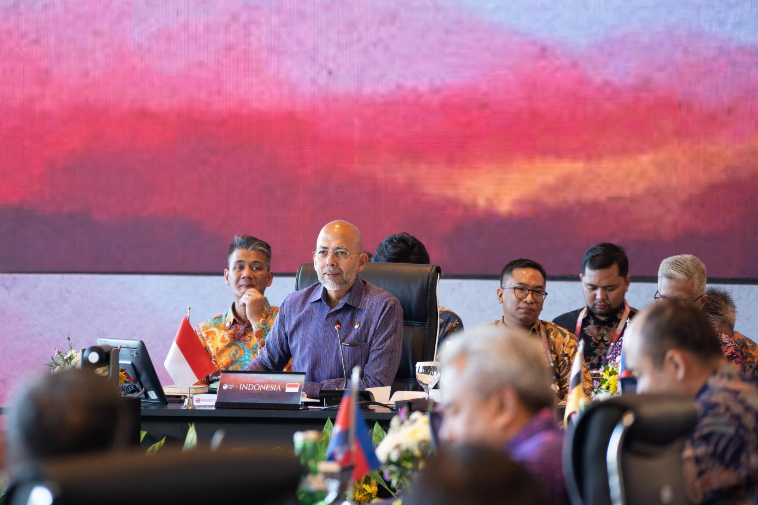

Director General for ASEAN Cooperation at the Indonesian Ministry of Foreign Affairs, Sidharto Reza Suryodipuro, who is also Indonesia's SOM Leader, chaired the ASEAN Senior Officials' Meeting (SOM). (Photo: Ministry of Foreign Affairs)

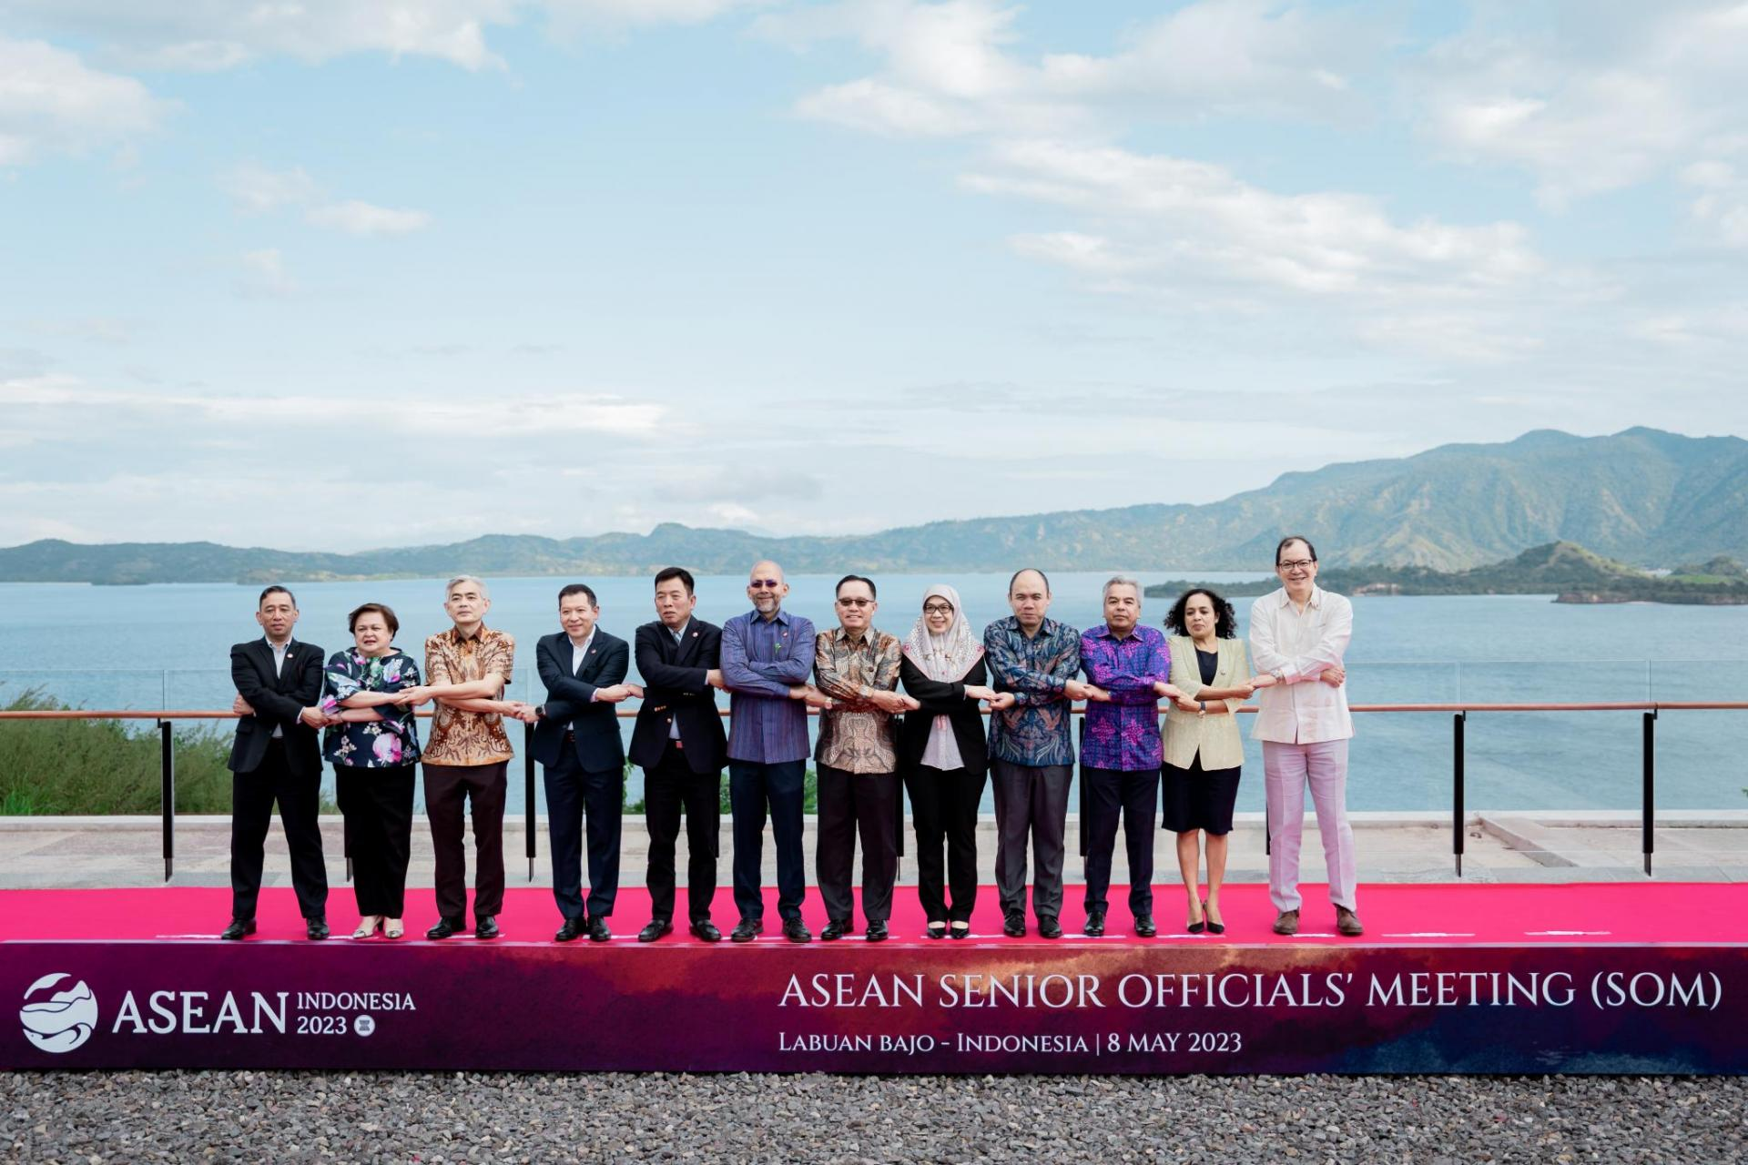

Family Photo of the ASEAN Senior Officials' Meeting (SOM) (Photo: Ministry of Foreign Affairs)